ГУАП

КАФЕДРА № 43

ОТЧЕТ   
ЗАЩИЩЕН С ОЦЕНКОЙ

ПРЕПОДАВАТЕЛЬ

|  |  |  |  |  |
| --- | --- | --- | --- | --- |
| Старший преподаватель |  |  |  | Путилова Н. В. |
| должность, уч. степень, звание |  | подпись, дата |  | инициалы, фамилия |

|  |
| --- |
| ОТЧЕТ О ЛАБОРАТОРНОЙ РАБОТЕ №3 |
| «Заполнение таблиц и модификация данных» |
| по курсу: ПРОЕКТИРОВАНИЕ БАЗ ДАННЫХ |
|  |

РАБОТУ ВЫПОЛНИЛ

|  |  |  |  |  |  |
| --- | --- | --- | --- | --- | --- |
| СТУДЕНТ ГР. № | 4831 |  |  |  | К. А. Корнющенков |
|  |  |  | подпись, дата |  | инициалы, фамилия |

Санкт-Петербург 2021

**Задание**

По аналогии с примерами, приведенными в п. 1 Выполнить вставку тестовых данных в таблицы, созданные в ходе выполнения лабораторной работы 2. В строках, вставляемых в таблицы, должны быть данные как удовлетворяющие, так и не удовлетворяющие условиям запросов, приведенных в варианте задания. Необходимо привести свои пример использования оператором update и delete и merge.

**Вариант**

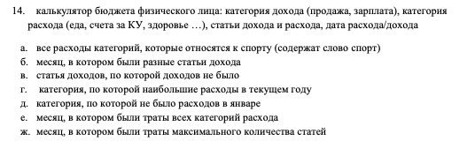

**Физическая модель**

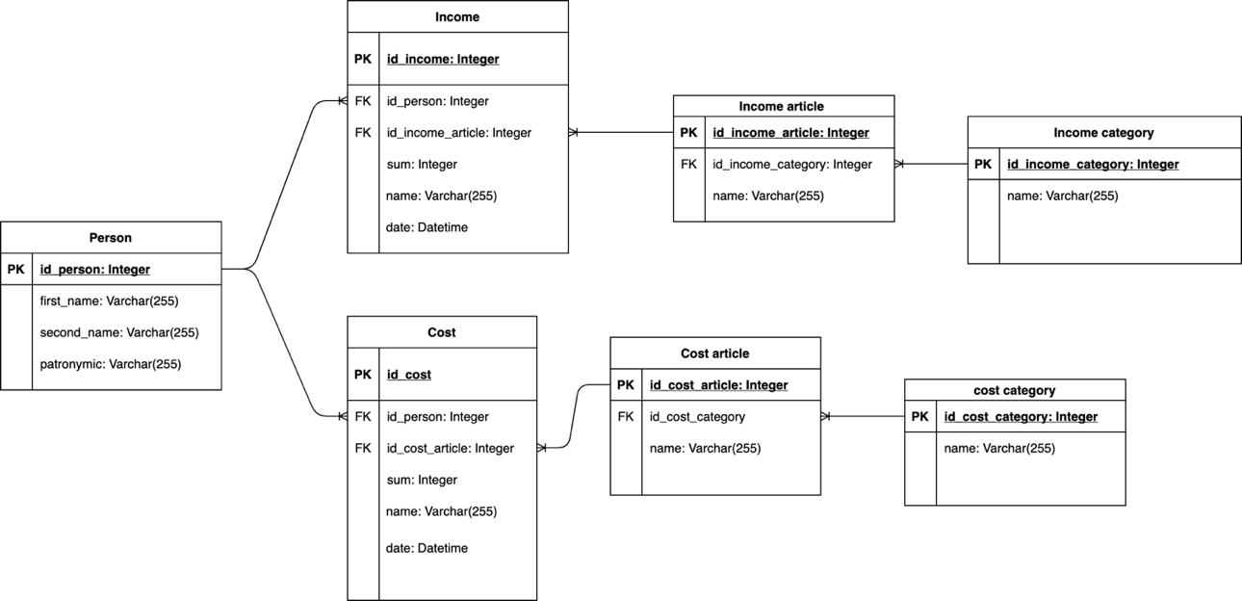

**Скрипт добавления данных в БД**

### Person ###

INSERT INTO Person (first_name, second_name, patronymic) VALUES ('Кирилл', 'Корнющенков', 'Алексеевич');

INSERT INTO Person (first_name, second_name, patronymic) VALUES ('Иван', 'Иванов', 'Иванович');

INSERT INTO Person (first_name, second_name, patronymic) VALUES ('Василий', 'Васильев', 'Васильевич');

### CostCategory ###

INSERT INTO CostCategory (name) VALUES ('Спорт');

INSERT INTO CostCategory (name) VALUES ('Здоровье');

INSERT INTO CostCategory (name) VALUES ('Путешествия');

INSERT INTO CostCategory (name) VALUES ('Рестораны и кафе');

INSERT INTO CostCategory (name) VALUES ('Отдых и развлечения');

### CostArticle ###

INSERT INTO CostArticle (name, id_cost_category)

VALUES (

'Абонимент в спортивный зал',

(SELECT id_cost_category from CostCategory WHERE name='Спорт')

);

INSERT INTO CostArticle (name, id_cost_category)

VALUES (

'Макдоналдс',

(SELECT id_cost_category from CostCategory WHERE name='Рестораны и кафе')

);

INSERT INTO CostArticle (name, id_cost_category)

VALUES (

'Delivery Club',

(SELECT id_cost_category from CostCategory WHERE name='Рестораны и кафе')

);

INSERT INTO CostArticle (name, id_cost_category)

VALUES (

'Первая полоса',

(SELECT id_cost_category from CostCategory WHERE name='Рестораны и кафе')

);

INSERT INTO CostArticle (name, id_cost_category)

VALUES (

'ЛЭтуаль',

(SELECT id_cost_category from CostCategory WHERE name='Здоровье')

);

### Cost ###

INSERT INTO Cost (id_person, id_cost_article, summ, name, costDate)

VALUES (

(SELECT id_person from Person WHERE first_name ='Кирилл' AND second_name='Корющенков'),

(SELECT id_cost_article from CostArticle WHERE name ='Абонимент в спортивный зал'),

4000,

'Годовой абинимент в спорт клуб - Здрововье 24/7',

CURRENT_TIMESTAMP()

);

INSERT INTO Cost (id_person, id_cost_article, summ, name, costDate)

VALUES (

(SELECT id_person from Person WHERE first_name ='Иван' AND second_name='Иванов'),

(SELECT id_cost_article from CostArticle WHERE name ='Макдоналдс'),

216,

'Поход в макдональдс',

CURRENT_TIMESTAMP()

);

INSERT INTO Cost (id_person, id_cost_article, summ, name, costDate)

VALUES (

(SELECT id_person from Person WHERE first_name ='Иван' AND second_name='Иванов'),

(SELECT id_cost_article from CostArticle WHERE name ='Макдоналдс'),

243,

'Поход в макдональдс',

CURRENT_TIMESTAMP()

);

### IncomeCategory ###

INSERT INTO IncomeCategory (name) VALUES ('Зачисления');

INSERT INTO IncomeCategory (name) VALUES ('Прочие поступления');

INSERT INTO IncomeCategory (name) VALUES ('Возврат, отмена операций');

INSERT INTO IncomeCategory (name) VALUES ('Перевод на карту');

INSERT INTO IncomeCategory (name) VALUES ('Внесение наличных');

### IncomeArticle ###

INSERT INTO IncomeArticle (name, id_income_category)

VALUES (

'Возврат денег',

(SELECT id_cost_category from IncomeCategory WHERE name='Возврат, отмена операций')

);

### Income ###

INSERT INTO Income (id_person, id_income_article , summ, name, incomeDate)

VALUES (

(SELECT id_person from Person WHERE first_name ='Иван' AND second_name='Иванов'),

(SELECT id_income_article from IncomeArticle WHERE name ='Возврат денег'),

750,

'Рамблер-Касса',

CURRENT_TIMESTAMP()

);

**Скрипт с примерами удаления данных из БД**

DELETE FROM CostCategory WHERE name = "Путешествия";

**Скрипт с примерами обновления данных из БД**

UPDATE CostCategory SET name = "Путешествие" WHERE name = "Путешествия" LIMIT 1;

**Скрипт с примерами MERGE данных из БД**

MERGE CostCategory USING CostCategory1 ON CostCategory.name = CostCategory1.name

WHEN MATCHED THEN CostCategory.name UPDATE SET CostCategory.name = CostCategory1.name

WHEN NOT MATCHED THEN INSERT (name) VALUES (CostCategory1.name)

WHEN NOT MATCHED BY SOURCE THEN DELETE

**Таблица тестовых данных**

|  |  |  |
| --- | --- | --- |
| **Текст запроса** | **Данные, удовлетворяющие условиям запросов** | **Данные, не удовлетворяющие условиям запросов** |
| Все расходы категорий, которые относятся к спорту (содержит слово спорт) | Спорт | Здоровье, Отдых и развлечения, Путешествие, Рестораны и кафе |
| Месяц, в котором были разные статьи дохода |  |  |
| Статья доходов, по которой доходов не было |  |  |
| Категория, по которой наибольшие расходы в текущем году |  |  |
| Категория, по которой не было расходов в январе |  |  |
| Месяц, в который были траты всех категорий расхода |  |  |
| Месяц, в котором были траты максимального количества статей |  |  |

**Вывод**

В ходе лабораторной работы была создан скрипт для наполнения таблиц базы данных данными. Была произведена работы по написанию скриптов изменения, удаления и слияния данных.

**Приложение 1**

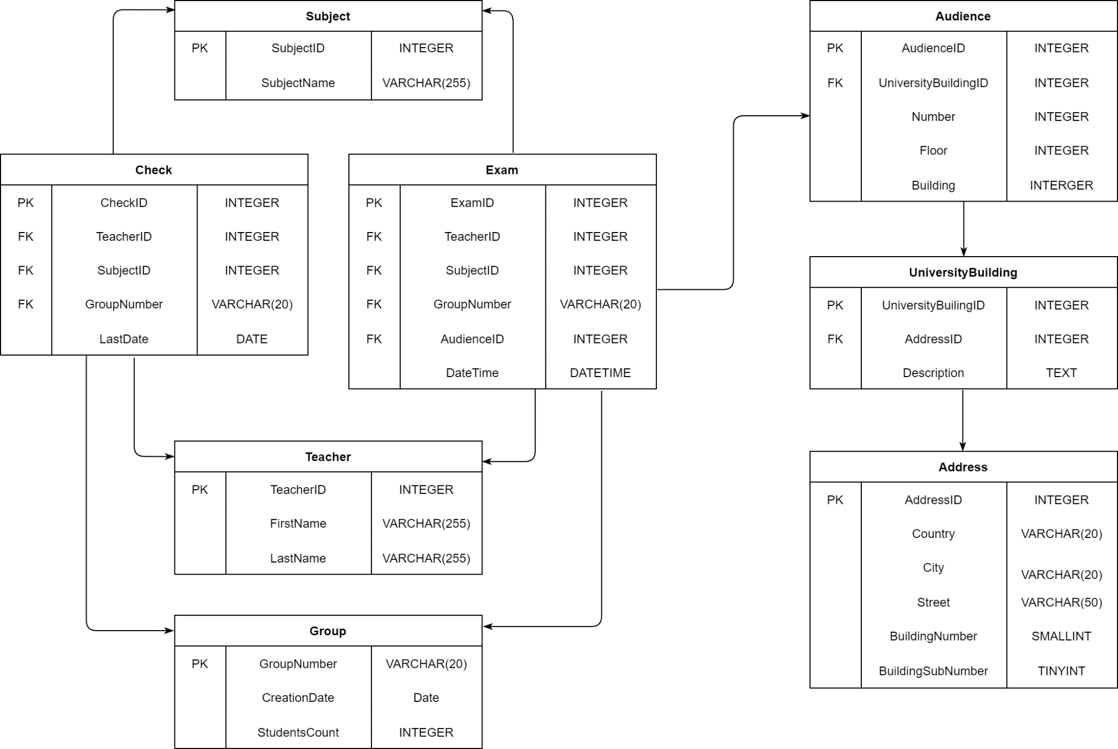

**Приложение 2**

TRUNCATE suai.subject_exam;  
TRUNCATE suai.subject_check;  
DELETE FROM suai.subject WHERE subject_id IS NOT NULL ;  
DELETE FROM suai.teacher WHERE teacher_id IS NOT NULL ;  
DELETE FROM suai.learn_group WHERE group_number IS NOT NULL ;  
DELETE FROM suai.audience WHERE audience_id IS NOT NULL ;  
DELETE FROM suai.university_building WHERE university_building_id IS NOT NULL ;  
DELETE FROM suai.address WHERE address_id IS NOT NULL ;  
  
  
  
*# ADDING DATA IN ADDRESS TABLE*INSERT INTO suai.address (country, city, street, building_number) VALUES ('Russia', 'Saint-Petersburg', 'Bolshaya-Morskaya', 67);  
INSERT INTO suai.address (country, city, street, building_number) VALUES ('Russia', 'Saint-Petersburg', 'Gastello Street', 15);  
INSERT INTO suai.address (country, city, street, building_number) VALUES ('Russia', 'Saint-Petersburg', 'Lensoveta Street', 14);  
  
  
  
*# ADDING DATA IN UNIVERSITY_BUILDING TABLE*INSERT INTO suai.university_building (address_id, description) VALUES (1, 'Отделение 1');  
INSERT INTO suai.university_building (address_id, description) VALUES (2, 'Отделение 2');  
INSERT INTO suai.university_building (address_id, description) VALUES (3, 'Отделение 3');  
  
  
  
*# ADDING DATA IN AUDIENCE TABLE*INSERT INTO suai.audience (university_building_id, number, floor, building) VALUES (1, 10, 4, 2);  
INSERT INTO suai.audience (university_building_id, number, floor, building) VALUES (1, 9, 4, 2);  
INSERT INTO suai.audience (university_building_id, number, floor, building) VALUES (1, 8, 4, 2);  
INSERT INTO suai.audience (university_building_id, number, floor, building) VALUES (2, 15, 4, 2);  
INSERT INTO suai.audience (university_building_id, number, floor, building) VALUES (2, 9, 2, 1);  
INSERT INTO suai.audience (university_building_id, number, floor, building) VALUES (2, 15, 4, 2);  
INSERT INTO suai.audience (university_building_id, number, floor, building) VALUES (3, 11, 3, 3);  
  
  
  
  
*# ADDING DATA IN LEARN GROUP TABLE*INSERT INTO suai.learn_group (group_number, creation_date) VALUES ('4832', '2018-8-1');  
INSERT INTO suai.learn_group (group_number, creation_date) VALUES ('4831', '2018-8-2');  
INSERT INTO suai.learn_group (group_number, creation_date) VALUES ('4836', '2018-8-3');  
INSERT INTO suai.learn_group (group_number, creation_date) VALUES ('М811', '2018-8-4');  
  
  
  
*#ADDING DATA IN TEACHER TABLE (Любые совпадения с реальными именами чистая случайность)*INSERT INTO suai.teacher (first_name, last_name) VALUES ('Надежда', 'Путилова');  
INSERT INTO suai.teacher (first_name, last_name) VALUES ('Марк', 'Поляк');  
INSERT INTO suai.teacher (first_name, last_name) VALUES ('Мария', 'Фаттахова');  
INSERT INTO suai.teacher (first_name, last_name) VALUES ('Евгений', 'Павлов');  
INSERT INTO suai.teacher (first_name, last_name) VALUES ('Павел', 'Степанов');  
INSERT INTO suai.teacher (first_name, last_name) VALUES ('Алексей', 'Попов');  
INSERT INTO suai.teacher (first_name, last_name) VALUES ('Сергей', 'Щекин');  
INSERT INTO suai.teacher (first_name, last_name) VALUES ('Ваня', 'Павлов');  
INSERT INTO suai.teacher (first_name, last_name) VALUES ('Виктор', 'Ничего-Не-Делающий');  
INSERT INTO suai.teacher (first_name, last_name) VALUES ('Человек', 'Для-Тестов');  
INSERT INTO suai.teacher (first_name, last_name) VALUES ('Георгий', 'Годзиашвили');  
INSERT INTO suai.teacher (first_name, last_name) VALUES ('Лариса', 'Вершинина');  
INSERT INTO suai.teacher (first_name, last_name) VALUES ('Анатолий', 'Смирнов');  
  
*# ADDING DATA IN SUBJECT TABLE*INSERT INTO suai.subject (subject_name) VALUES ('Проектирование базы данных');  
INSERT INTO suai.subject (subject_name) VALUES ('Программирование мобильных устройств');  
INSERT INTO suai.subject (subject_name) VALUES ('Программирование встроенных приложений');  
INSERT INTO suai.subject (subject_name) VALUES ('Функциональное и логическое программирование');  
INSERT INTO suai.subject (subject_name) VALUES ('Управление качеством программного обеспечения');  
INSERT INTO suai.subject (subject_name) VALUES ('Операционные системы');  
INSERT INTO suai.subject (subject_name) VALUES ('Прикладная физическая культура');  
INSERT INTO suai.subject (subject_name) VALUES ('Прикладные модели оптимизации');  
INSERT INTO suai.subject (subject_name) VALUES ('Проектирование программных систем');  
INSERT INTO suai.subject (subject_name) VALUES ('Проектирование программных систем');  
INSERT INTO suai.subject (subject_name) VALUES ('Никому не нужный предмет для тестов');  
  
  
  
*# ADDING DATA IN SUBJECT EXAM TABLE*INSERT INTO suai.subject_exam (teacher_id, subject_id, group_id, audience_id, date_time) VALUES (1, 1, '4836', 2, '2021-06-26 11:00:00');  
INSERT INTO suai.subject_exam (teacher_id, subject_id, group_id, audience_id, date_time) VALUES (11, 13, 'М811', 1, '2021-06-25 11:00:00');  
INSERT INTO suai.subject_exam (teacher_id, subject_id, group_id, audience_id, date_time) VALUES (1, 1, '4831', 2, '2021-06-24 14:00:00');  
INSERT INTO suai.subject_exam (teacher_id, subject_id, group_id, audience_id, date_time) VALUES (1, 1, '4832', 2, '2021-06-24 11:00:00');  
INSERT INTO suai.subject_exam (teacher_id, subject_id, group_id, audience_id, date_time) VALUES (6, 3, '4836', 1, '2021-06-19 11:00:00');  
INSERT INTO suai.subject_exam (teacher_id, subject_id, group_id, audience_id, date_time) VALUES (6, 3, '4831', 1, '2021-06-18 14:00:00');  
INSERT INTO suai.subject_exam (teacher_id, subject_id, group_id, audience_id, date_time) VALUES (6, 3, '4832', 1, '2021-06-18 11:00:00');  
INSERT INTO suai.subject_exam (teacher_id, subject_id, group_id, audience_id, date_time) VALUES (5, 4, '4836', 3, '2021-06-12 11:00:00');  
INSERT INTO suai.subject_exam (teacher_id, subject_id, group_id, audience_id, date_time) VALUES (5, 4, '4831', 2, '2021-06-10 14:00:00');  
INSERT INTO suai.subject_exam (teacher_id, subject_id, group_id, audience_id, date_time) VALUES (5, 4, '4832', 3, '2021-06-10 11:00:00');  
INSERT INTO suai.subject_exam (teacher_id, subject_id, group_id, audience_id, date_time) VALUES (1, 1, 'М811', 2, '2021-06-05 14:00:00');  
INSERT INTO suai.subject_exam (teacher_id, subject_id, group_id, audience_id, date_time) VALUES (2, 6, '4836', 2, '2021-06-03 11:00:00');  
INSERT INTO suai.subject_exam (teacher_id, subject_id, group_id, audience_id, date_time) VALUES (2, 6, '4831', 2, '2021-06-02 14:00:00');  
INSERT INTO suai.subject_exam (teacher_id, subject_id, group_id, audience_id, date_time) VALUES (2, 6, '4832', 2, '2021-06-02 11:00:00');  
INSERT INTO suai.subject_exam (teacher_id, subject_id, group_id, audience_id, date_time) VALUES (12, 11, 'М811', 3, '2021-05-30 14:00:00');  
INSERT INTO suai.subject_exam (teacher_id, subject_id, group_id, audience_id, date_time) VALUES (3, 8, '4836', 1, '2021-05-29 11:00:00');  
INSERT INTO suai.subject_exam (teacher_id, subject_id, group_id, audience_id, date_time) VALUES (3, 8, '4831', 1, '2021-05-28 14:00:00');  
INSERT INTO suai.subject_exam (teacher_id, subject_id, group_id, audience_id, date_time) VALUES (3, 8, '4832', 1, '2021-05-28 11:00:00');  
INSERT INTO suai.subject_exam (teacher_id, subject_id, group_id, audience_id, date_time) VALUES (2, 6, 'М811', 3, '2021-05-25 11:00:00');  
  
  
*# ADDING DATA IN SUBJECT CHECK TABLE*INSERT INTO suai.subject_check (teacher_id, subject_id, group_id, last_date) VALUES (4, 9, '4832', '2021-05-23');  
INSERT INTO suai.subject_check (teacher_id, subject_id, group_id, last_date) VALUES (7, 2, '4832', '2021-05-23');  
INSERT INTO suai.subject_check (teacher_id, subject_id, group_id, last_date) VALUES (8, 7, '4832', '2021-05-23');  
INSERT INTO suai.subject_check (teacher_id, subject_id, group_id, last_date) VALUES (5, 5, '4832', '2021-05-23');  
INSERT INTO suai.subject_check (teacher_id, subject_id, group_id, last_date) VALUES (4, 9, '4831', '2021-05-22');  
INSERT INTO suai.subject_check (teacher_id, subject_id, group_id, last_date) VALUES (7, 2, '4831', '2021-05-22');  
INSERT INTO suai.subject_check (teacher_id, subject_id, group_id, last_date) VALUES (8, 7, '4831', '2021-05-22');  
INSERT INTO suai.subject_check (teacher_id, subject_id, group_id, last_date) VALUES (5, 5, '4831', '2021-05-22');  
INSERT INTO suai.subject_check (teacher_id, subject_id, group_id, last_date) VALUES (4, 9, '4836', '2021-05-21');  
INSERT INTO suai.subject_check (teacher_id, subject_id, group_id, last_date) VALUES (7, 2, '4836', '2021-05-21');  
INSERT INTO suai.subject_check (teacher_id, subject_id, group_id, last_date) VALUES (8, 7, '4836', '2021-05-21');  
INSERT INTO suai.subject_check (teacher_id, subject_id, group_id, last_date) VALUES (5, 5, '4836', '2021-05-21');  
INSERT INTO suai.subject_check (teacher_id, subject_id, group_id, last_date) VALUES (11, 12, 'М811', '2021-05-20');  
INSERT INTO suai.subject_check (teacher_id, subject_id, group_id, last_date) VALUES (13, 10, 'М811', '2021-05-20');  
INSERT INTO suai.subject_check (teacher_id, subject_id, group_id, last_date) VALUES (8, 8, 'М811', '2021-05-20');

**Приложение 3**

DELETE FROM testplayground.tableone WHERE Column1 >= 0; *# TRUNCATE*DELETE FROM testplayground.tabletwo WHERE Column1 >= 0; *# TRUNCATE*DELETE FROM testplayground.tablethree WHERE Column1 >= 0; *# TRUNCATE*insert into testplayground.tableone (Column2) VALUES ('1');   
insert into testplayground.tableone (Column2) VALUES ('2');   
insert into testplayground.tableone (Column2) VALUES ('3');   
insert into testplayground.tableone (Column2) VALUES ('4');   
insert into testplayground.tableone (Column2) VALUES ('5');   
insert into testplayground.tableone (Column2) VALUES ('6');   
  
insert into testplayground.tabletwo (Column2) VALUES ('1');   
insert into testplayground.tabletwo (Column2) VALUES ('3');   
insert into testplayground.tabletwo (Column2) VALUES ('6');   
insert into testplayground.tabletwo (Column2) VALUES ('10');   
insert into testplayground.tabletwo (Column2) VALUES ('11');   
  
  
DELETE LOW_PRIORITY QUICK testplayground.tableone  
FROM testplayground.tableone, testplayground.tabletwo WHERE testplayground.tableone.Column2 = testplayground.tabletwo.Column2;  
  
DELETE FROM testplayground.tableone USING testplayground.tableone, testplayground.tabletwo  
WHERE tableone.Column2 = tabletwo.Column2  
ORDER BY tableone.Column1

**Приложение 4**

UPDATE LOW_PRIORITY IGNORE suai.teacher   
SET first_name = 'Виктор' WHERE first_name = 'Витёк' LIMIT 1;  
  
UPDATE LOW_PRIORITY IGNORE suai.address  
SET street = 'Большая-Морская' WHERE street = 'Bolshaya-Morskaya' LIMIT 1;  
  
  
UPDATE suai.address  
SET street = 'Улица Гастелло' WHERE street = 'Gastello Street' LIMIT 1;  
  
  
UPDATE suai.address  
SET street = 'Улица Ленсовета' WHERE street = 'Lensoveta Street' LIMIT 1;

**Приложение 5**

MERGE suai.subject_exam

USING suai.subject_exam_regenerated

ON suai.subject_exam.exam_key = suai.subject_exam_regenerated.exam_key

WHEN MATCHED THEN # WHEN MATHCHED AND suai.subject_exam.Column2 != suai.subject_exam_regenerated.NewDateTime

UPDATE

SET suai.subject_exam.date_time = suai.subject_exam_regenerated.new_date_time

WHEN NOT MATCHED THEN

INSERT (teacher_id, subject_id, group_number, audience_id, date_time)

VALUES (suai.subject_exam_regenerated.new_teacher_id,

suai.subject_exam_regenerated.new_subject_id,

suai.subject_exam_regenerated.new_group_number,

suai.subject_exam_regenerated.new_audience_id,

suai.subject_exam_regenerated.new_date_time)

WHEN NOT MATCHED BY SOURCE THEN

DELETE